**Criteria-5**

**5.2.2 Percentage of students qualifying in state/national/ international level examinations during the last five years**

**(eg: IIT/JAM/NET/SLET/GATE/GMAT/GPAT/CLAT/CAT/ GRE/TOEFL/ IELTS/Civil Services/State government examinations etc.)**

|  |  |  |  |
| --- | --- | --- | --- |
| **Year** | **Registration number/roll number for the exam** | **Names of students qualified** | **Name of the qualifying exam** |
|
| 2022-2023 | TL01040587 | **Birkul Aryasri** | CUET |
| 2022-2023 | TL01010049 | **ANANTHULA VISHWAROOPA** | CUET |
| 2022-2023 | TL01040044 | **Kamera Deepa** | CUET |
| 2022-2023 | TL02020239 | **Jadi Vineetha** | CUET |
| 2022-2023 | TL01040035 | **Moulkar Shireesha** | CUET |
| 2022-2023 | TL08010296 | **Kallur Tejashwini** | CUET |
| 2022-2023 | TL08010023 | **Bandi Soujanya** | CUET |
| 2022-2023 | TL08010003 | **Suryavamshi Laxmi** | CUET |
| 2022-2023 | TL08010240 | **Arshawar Vennela** | CUET |
| 2022-2023 | TL08010022 | **Mantri Shravani** | CUET |
| 2022-2023 | TL01040460 | **Baddam Thanusri** | CUET |
| 2022-2023 | TL01040562 | **CHANDEKAR NAGASRI** | CUET |
| 2022-2023 | TL01040449 | **Munjam Poojarani** | CUET |
| 2022-2023 | TL11210058 | **Darla Aishwarya** | CUET |
| 2022-2023 | TL01042966 | **BARUKUNTA SHARANYA** | CUET |
| 2022-2023 | TL01410353 | **Pilli Vaishali** | CUET |
| 2022-2023 | TL02020037 | **DURGAM ABHINAYA** | CUET |
| 2022-2023 | TL02010029 | **BOGA BHAVANI** | CUET |
| 2022-2023 | TL08010079 | **Jella Ujwala** | CUET |
| 2022-2023 | C23035418 | Gajula Hemeema | TISS |
| 2022-2023 | C23035459 | kutikela Jyothi | TISS |
| 2022-2023 | C23035473 | Padigela Sandhya | TISS |
| 2022-2023 | 23PGR203560 | J.Susmitha | APU |
| 2022-2023 | 22188803 | SARASWATHI SANGARTHI | CAT |
|  |  |  |  |
| 2021-2022 | 223510112660 | RAVEENA ANANTHULA | CUET |
| 2021-2022 | 223510112550 | POOJA ANNEPAGA | CUET |
| 2021-2022 | 223510117943 | MALAVIKA CHIRRA | CUET |
| 2021-2022 | 223510112962 | ASHWINI DANTHABHAKTHULA | CUET |
| 2021-2022 | 223510118907 | SOUMYA DURGAM | CUET |
| 2021-2022 | 223510111460 | DEEPIKA GADCHANDA | CUET |
| 2021-2022 | 223510111235 | POOJITHA KONDAMADUGU | CUET |
| 2021-2022 | 223510118629 | GANGASAGARA KUTHADI | CUET |
| 2021-2022 | 223510111284 | PRAMEELA KUTHADI | CUET |
| 2021-2022 | 223510111199 | DEEPA MADHNURE | CUET |
| 2021-2022 | 223510110686 | SINDHUJA MEERA | CUET |
| 2021-2022 | 223510139238 | SRAVANI MESRAM | CUET |
| 2021-2022 | 223510096270 | CHANDINI MUNESHWAR | CUET |
| 2021-2022 | 223510118801 | NAVANEETHA AKULA | CUET |
| 2021-2022 | 223510083365 | SWETHA PATHI | CUET |
| 2021-2022 | 223510111604 | SHIREESHA MUDDAM | CUET |
| 2021-2022 | 223510112459 | SRUTHI BANDARI | CUET |
| 2021-2022 | 223510092904 | HARISHITHA TIRUNAGARI | CUET |
| 2021-2022 | 223510112766 | THIRUMALA VELUMALA | CUET |
| 2021-2022 | 223510093276 | VANDANA YARA | CUET |
| 2021-2022 | 223510172600 | PALLAVI THODETI | CUET |
| 2021-2022 | 223510171533 | KEERTHANA AJMEERA | CUET |
| 2021-2022 | 223510172718 | TEJASRI ATHKURI | CUET |
| 2021-2022 | 223510172207 | RAMYA CHATAGOPURA | CUET |
| 2021-2022 | 223510192595 | SRILATHA DAGAM | CUET |
| 2021-2022 | 223510175884 | VANAJA DURGAM | CUET |
| 2021-2022 | 223510186134 | VEENA DURGAM | CUET |
| 2021-2022 | 223510185595 | SHYAMALA GODARI | CUET |
| 2021-2022 | 223510172700 | SARITHA GOMASA | CUET |
| 2021-2022 | 223510174702 | SAI NITHYA GOMASI | CUET |
| 2021-2022 | 223510173979 | DIVYA GUMMULA | CUET |
| 2021-2022 | 223510142226 | ISHWARYA JADHAV | CUET |
| 2021-2022 | 223510172501 | SONALI JADHAV | CUET |
| 2021-2022 | 223510171325 | SHIREESHA JADI | CUET |
| 2021-2022 | 223510173451 | CHAITHANYA KADHAM | CUET |
| 2021-2022 | 223510171759 | SHARADHA KANCHARI | CUET |
| 2021-2022 | 223510171141 | ARCHANA KOTARI | CUET |
| 2021-2022 | 223510172371 | GANGARANI MUDUGULA | CUET |
| 2021-2022 | 223510173530 | SANDHYARANI MUTHYALA | CUET |
| 2021-2022 | 223510172791 | SWAPNA OMKARI | CUET |
| 2021-2022 | 223510119536 | PRIYANKA TEJA PODETI | CUET |
| 2021-2022 | 223510175816 | MOUNIKA POKKURI | CUET |
| 2021-2022 | 223510175749 | PRAVALIKA DUDDOLLA | CUET |
| 2021-2022 | 223510119536 | POOJA PUDURI | CUET |
| 2021-2022 | 223510174641 | POOJA PYATODU | CUET |
| 2021-2022 | 223510078921 | JYOTHSNARANI BIRKULA | CUET |
| 2021-2022 | 223510130096 | SRUTHILAYA NYALAKALA | CUET |
| 2021-2022 | 223510130645 | MANJULA PANCHATHI | CUET |
| 2021-2022 | 223510196254 | NIROJA BAIKAM | CUET |
| 2021-2022 | 223510185274 | NAVYA SRI BANDAPELLI | CUET |
| 2021-2022 | 223510182746 | SUPRIYA BHATTI | CUET |
| 2021-2022 | 223510155940 | SRIVANI GUGLAVATH | CUET |
| 2021-2022 | 223510182894 | CHANDANA MAGGIDI | CUET |
| 2021-2022 | 223510130491 | AKSHITHA MEKALA | CUET |
| 2021-2022 | 223510183008 | SRIJA PUPPALA | CUET |
| 2021-2022 | 223510112858 | SNEHITHA SANDUGARI | CUET |
| 2021-2022 | 223510132954 | ARPITHA SHEWALE | CUET |
| 2021-2022 | 223510179042 | SRIKANYA SONNA | CUET |
| 2021-2022 | 223510159668 | RUCHITHA BAJARU | CUET |
| 2021-2022 | 223510193488 | NIKHITHA BANDI | CUET |
| 2021-2022 | 223510193506 | YOGITHA BARADOLLA | CUET |
| 2021-2022 | 223510239036 | SAISHIRISHA BAIRA | CUET |
| 2021-2022 | 223510195816 | SRUJANA CHATLA | CUET |
| 2021-2022 | 223510195295 | ANKITHA DHUBBA | CUET |
| 2021-2022 | 223510198240 | SRINIJA GURUPELLY | CUET |
| 2021-2022 | 223510164028 | ARUNA KONDRA | CUET |
| 2021-2022 | 223510198392 | DEEPIKA KUSTAPURAM | CUET |
| 2021-2022 | 223510137861 | SREEJA MARKARI | CUET |
| 2021-2022 | 223510164967 | RAMADEVI PEDDAGONDA | CUET |
| 2021-2022 | 223510142028 | POOJITHA MADDELA | CUET |
| 2021-2022 | 223510195061 | PRIYANKA RAGAM | CUET |
| 2021-2022 | 223510191660 | AKHILA SANGE | CUET |
| 2021-2022 | 223510140379 | LAXMI ADDIGA | CUET |
| 2021-2022 | 223510117560 | DEEPIKA AMBATI | CUET |
| 2021-2022 | 223510195412 | SANDHYA AVUNURI | CUET |
| 2021-2022 | 223510112793 | MALLESHWARI BAIKAM | CUET |
| 2021-2022 | 223510117323 | KAVYASRI BONAGIRI | CUET |
| 2021-2022 | 223510117239 | PRANITHA BOREKAR | CUET |
| 2021-2022 | 223510204337 | SREEJA CHANDRE | CUET |
| 2021-2022 | 223510119154 | PRASANNA GADDAM | CUET |
| 2021-2022 | 223510118567 | SWARNALATHA GADEKAR | CUET |
| 2021-2022 | 223510195992 | HARIPRIYA GANDLA | CUET |
| 2021-2022 | 223510194700 | SRILATHA GUNDAVENI | CUET |
| 2021-2022 | 223510195162 | MAITHILI KADAPATHRI | CUET |
| 2021-2022 | 223510117670 | SAI KEERTHANA KANKALLA | CUET |
| 2021-2022 | 223510119102 | LAVANYA KERLA | CUET |
| 2021-2022 | 223510103113 | JYOTHSNA KHANDKE | CUET |
| 2021-2022 | 223510117534 | VARUNDHA KOPPULA | CUET |
| 2021-2022 | 223510118277 | PRASANNA MANCHALA | CUET |
| 2021-2022 | 223510119061 | PRIYANKA MORLE | CUET |
| 2021-2022 | 223510117557 | JYOSHNA NALUVALA | CUET |
| 2021-2022 | 223510118690 | MOUNIKA NAMPELLI | CUET |
| 2021-2022 | 223510195751 | RANI NARAYANOLLA | CUET |
| 2021-2022 | 223510117868 | PRIYANKA ORREM | CUET |
| 2021-2022 | 223510093352 | YOGITHA PENTEWAR | CUET |
| 2021-2022 | 223510093689 | SUMITHA POTTAVATHI | CUET |
| 2021-2022 | 223510093869 | NAVANEETHA PUTTI | CUET |
| 2021-2022 | 223510194676 | SPANDANA RAJARAPU | CUET |
| 2021-2022 | 223510093491 | SWETHA VALGOT | CUET |
| 2021-2022 | C22035928 | V.Thirumala | TISS |
| 2021-2022 | C22025789 | A.Keerthana | TISS |
| 2021-2022 | C22045566 | N.Soujanya | TISS |
| 2021-2022 | C22045503 | J.Aishwarya | TISS |
| 2021-2022 | C22041635 | P.Priyanka Teja | TISS |
| 2021-2022 | C22042526 | J.Sonali | TISS |
| 2021-2022 | C22041829 | R.Durga | TISS |
| 2021-2022 | C22046680 | S.Arpitha | TISS |
| 2021-2022 | C22047005 | G.Sneha | TISS |
| 2021-2022 | C22036029 | K.Varundha | TISS |
| 2021-2022 | C22031221 | Ch.Sreeja | TISS |
| 2021-2022 | C22034551 | B.Pranitha | TISS |
| 2021-2022 | CTUAP21001431 | PINNAM KRISHNAVENI | CTUAP |
| 2021-2022 | CTUAP21001621 | GUNDENA SAI SREE | CTUAP |
| 2021-2022 | 11201188 | Rakshitha Reddy | HCU |
| 2021-2022 | PG219154 | R.Srinija | CUCET |
|  |  |  |  |
| 2020-2021 | C21044230 | K.GOUTHAMI | TISS |
| 2020-2021 | C21040172 | R.MADHULATHA | TISS |
| 2020-2021 | C21048686 | B.SREEJA | TISS |
| 2020-2021 | C21044302 | R.MANASA | TISS |
| 2020-2021 | C21045031 | P.VIDYASHEELA | TISS |
| 2020-2021 | C21039313 | E.MEGHANA | TISS |
| 2020-2021 | C21045243 | M.RAVALI | TISS |
| 2020-2021 | C21050190 | D.SUJATHA | TISS |
| 2020-2021 | C21053037 | G.NAGMA | TISS |
| 2020-2021 | C21039704 | A.AHWINI | TISS |
| 2020-2021 | C21048589 | M.SRUTHI | TISS |
| 2020-2021 | C21044827 | R.DURGA | TISS |
| 2020-2021 | C21051191 | J.VANI | TISS |
| 2020-2021 | C21048651 | CH.RATHNAKUMARI | TISS |
| 2020-2021 | C21050360 | R.KALPANA | TISS |
| 2020-2021 |  | J.Akhila | NIT Calicut |
|  |  |  |  |
| 2019-2020 | C20020813 | G.Akhila | TISS |
|  |  |  |  |
| 2018-2019 | C19056465 | G.ROSHINI | TISS |
| 2018-2019 | C19056877 | L.MANOGNYA | TISS |
| 2018-2019 | C19033804 | W.SHUBHANGINI | TISS |
| 2018-2019 | 1935178 | D.GNANESHWARI | UOH |
| 2018-2019 | 1908141 | K.PRAVANYA | NIMCET |

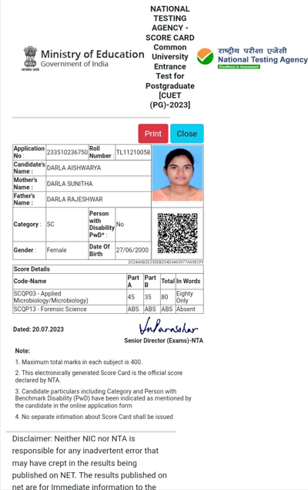

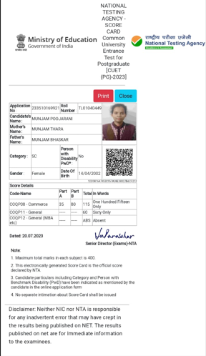

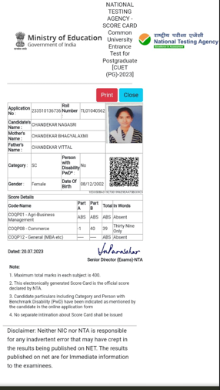

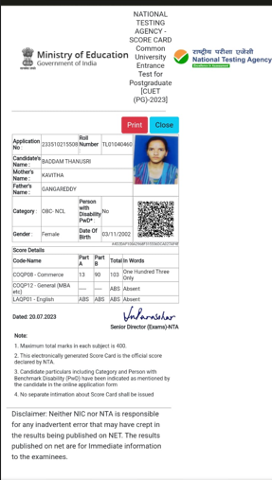

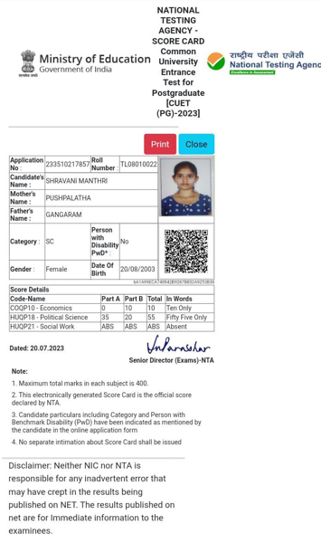

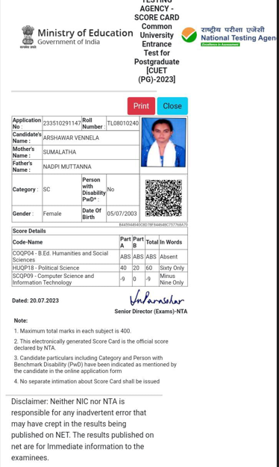

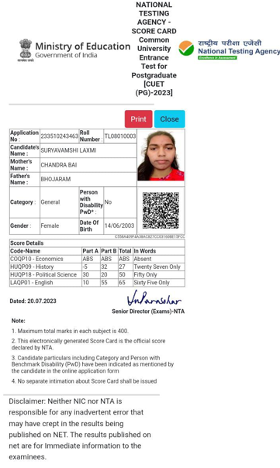

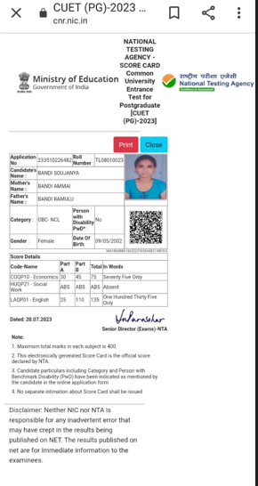

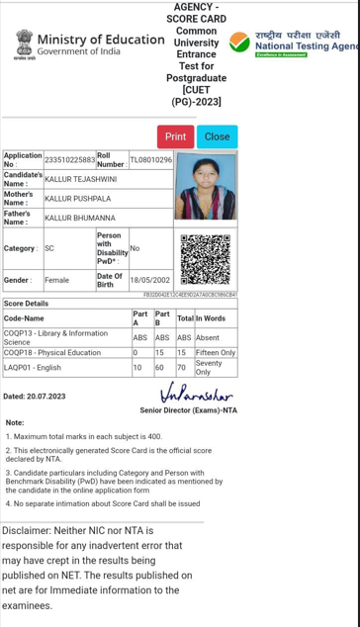

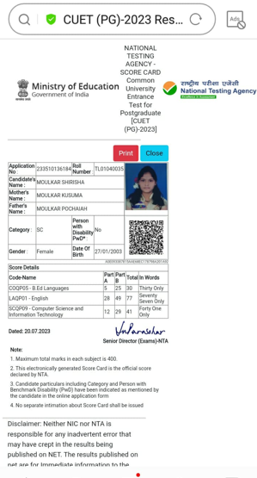

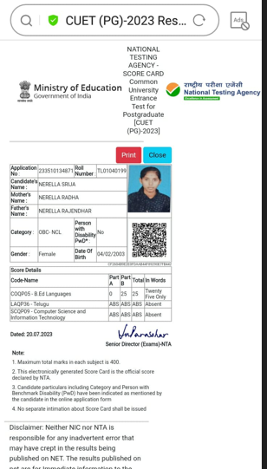

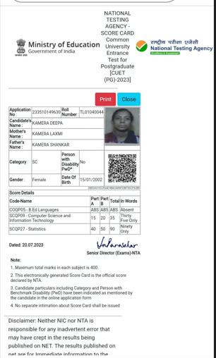

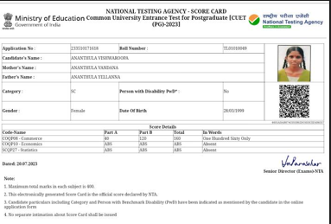

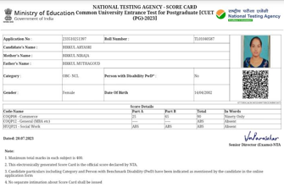

|  |  |  |  |
| --- | --- | --- | --- |
| **CUET 2023 RESULTS TSWRDCW NIRMAL** | | | |
| **SUBJECT** | **CUET RANKS** | **HALLTICKET NO** | **NAME** |
| PHYSICS | 45 | 233510170124 | J.UJWALA |
| CHEMISTRY | 43 | 233510170226 | BOGA.BHAVANI |
| MATHEMATICS | 34 | 233510170226 | BOGA.BHAVANI |
| CHEMISTRY | 37 | 233510359220 | D.ABHINAYA |
| MATHEMATICS | 40 | 233510359220 | D.ABHINAYA |
| PHYSICS | 21 | 233510257595 | P.VAISHALI |
| MATHEMATICS | 31 | 233510176102 | B.SHARANYA |
| MICROBIOLOGY | 80 | 233510236750 | D.AISHWARYA |
| COMMERCE | 115 | 233510169921 | MUNJAM.POOJARANI |
| GENERAL | 60 | 233510169921 | MUNJAM.POOJARANI |
| COMMERCE | 39 | 233510136736 | CH.NAGASRI |
| COMMERCE | 103 | 233510215508 | B.THANUSRI |
| POLITICAL SCIENCE | 55 | 233510217857 | M.SHRAVANI |
| ECONOMICS | 10 | 233510217857 | M.SHRAVANI |
| POLITICAL SCIENCE | 60 | 233510291147 | A.VENNELA |
| HISTORY | 27 | 233510243463 | S.LAXMI |
| POLITICAL SCIENCE | 50 | 233510243463 | S.LAXMI |
| ENGLISH | 65 | 233510243463 | S.LAXMI |
| ENGLISH | 135 | 233510226482 | B.SOUJANYA |
| ECONOMICS | 75 | 233510226482 | B.SOUJANYA |
| ENGLISH | 70 | 233510225883 | K.TEJASHWINI |
| PHYSICAL EDUCATION | 15 | 233510225883 | K.TEJASHWINI |
| B.ED LANGUAGES | 30 | 233510136184 | M.SHIRISHA |
| ENGLISH | 77 | 233510136184 | M.SHIRISHA |
| COMPUTER SCIENCE | 41 | 233510136184 | M.SHIRISHA |
| B.ED LANGUAGES | 25 | 233510134871 | N.SREEJA |
| COMPUTER SCIENCE | 35 | 233510149630 | K.DEEPA |
| STATISTICS | 90 | 233510149630 | K.DEEPA |
| COMMERCE | 160 | 233510171618 | A.VISHWAROOPA |
| COMMERCE | 90 | 233510251397 | B.SRYASRI |

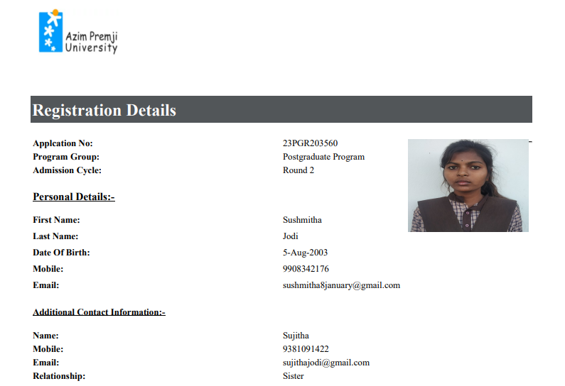

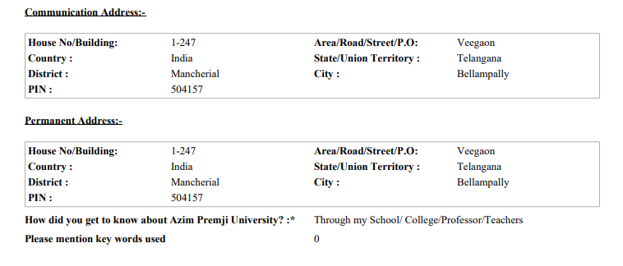

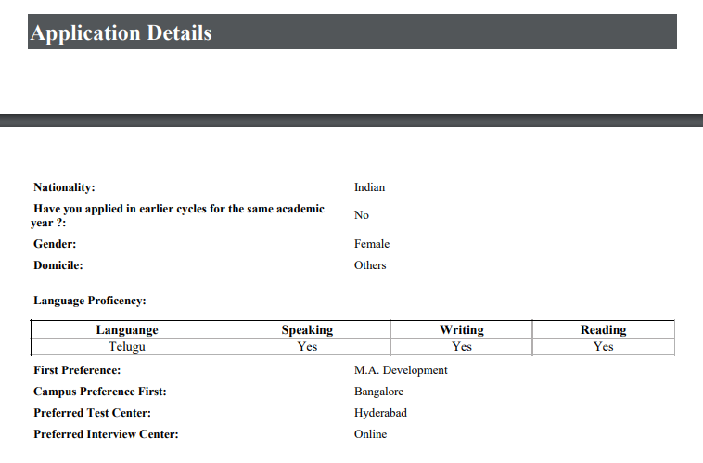

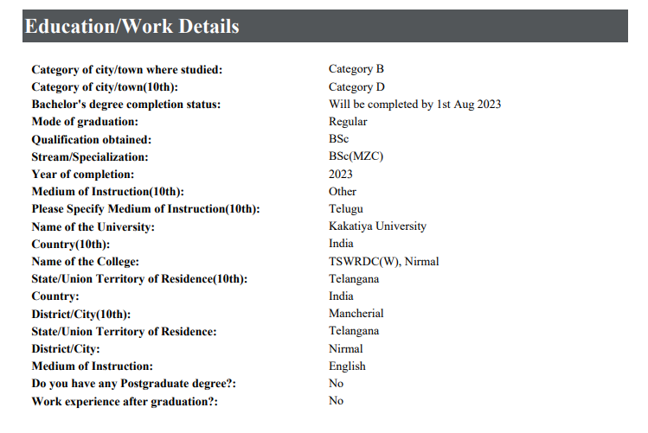 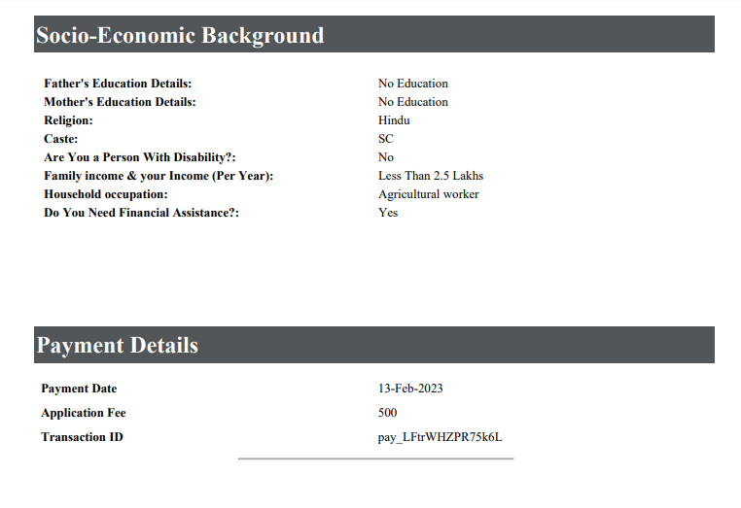

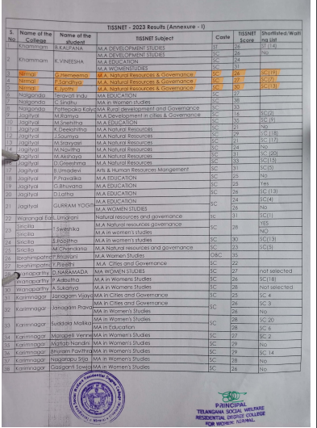

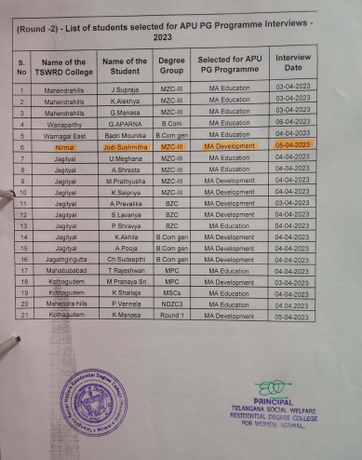

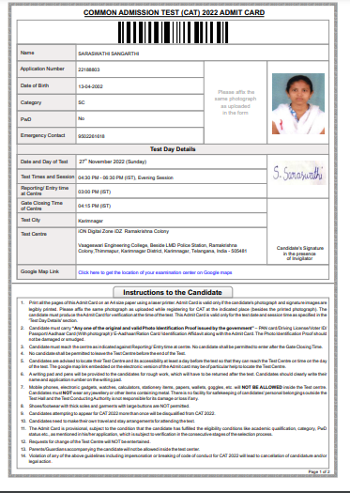

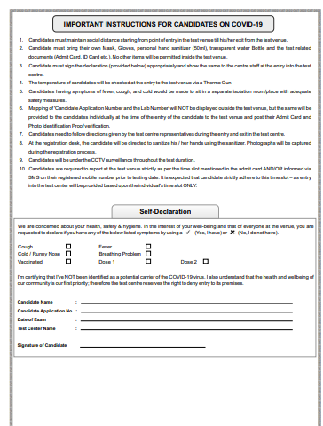

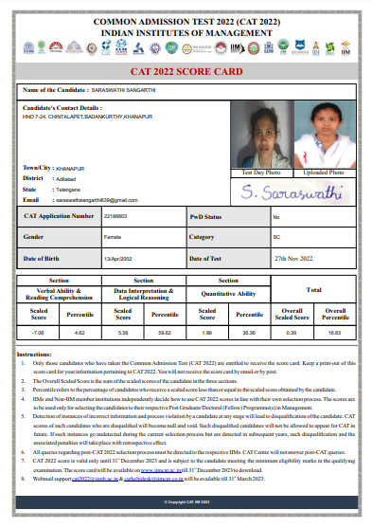

**2021-2022 Proofs**

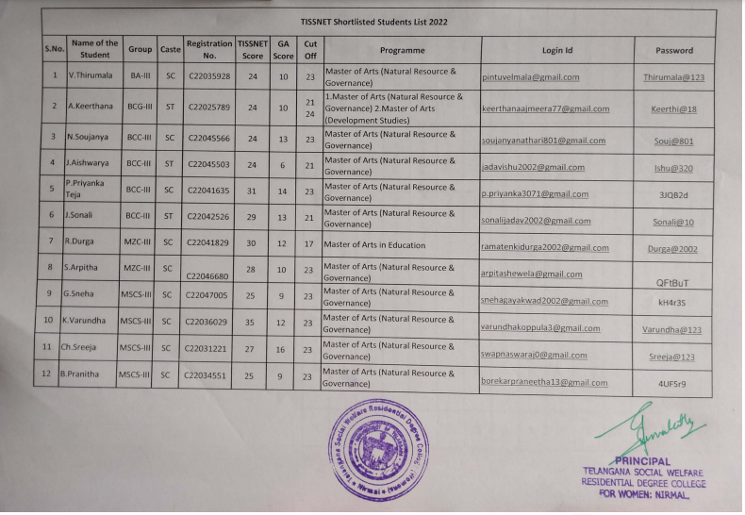

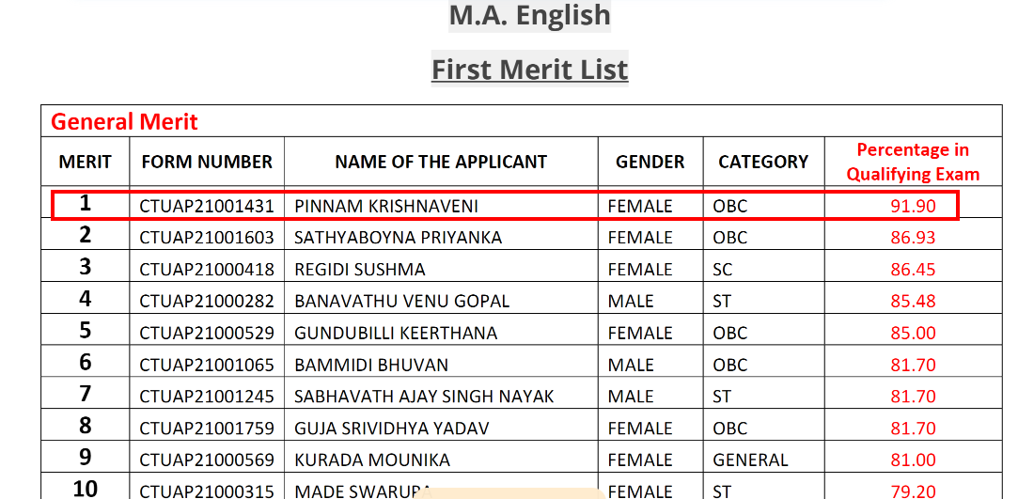

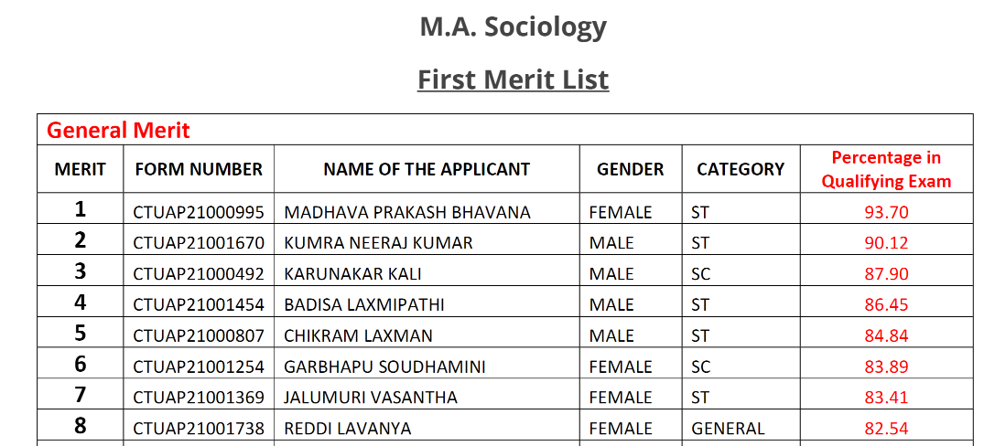

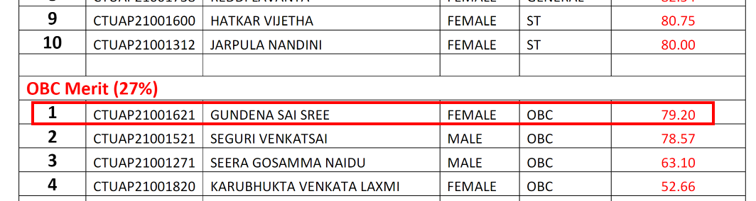

|  |  |  |  |  |  |  |  |  |
| --- | --- | --- | --- | --- | --- | --- | --- | --- |
| **CUET Application Details 2022** | | | | | | | | |
| **Sno** | **Class** | **Group** | [**H.T.No**](http://h.t.no/) | **Name of the student** | **Caste** | **Contact No.** | **CUET Application Number** | **Password** |
|
| 1 | [BA](http://b.com/) | HEP | 636201002 | RAVEENA ANANTHULA | SC | 6302440257 | 223510112660 | Ravi@2001 |
| 2 | BA | HEP | 636201003 | POOJA ANNEPAGA | SC | 9441529863 | 223510112550 | Pooja@2001 |
| 3 | BA | HEP | 636201010 | MALAVIKA CHIRRA | SC | 7702638382 | 223510117943 | Mala@2003 |
| 4 | BA | HEP | 636201012 | ASHWINI DANTHABHAKTHULA | BC-B | 8179735777 | 223510112962 | Ashw@2002 |
| 5 | BA | HEP | 636201013 | SOUMYA DURGAM | SC | 9515694331 | 223510118907 | Soum@2002 |
| 6 | BA | HEP | 636201015 | DEEPIKA GADCHANDA | SC | 9491468212 | 223510111460 | Deep@2002 |
| 7 | BA | HEP | 636201019 | POOJITHA KONDAMADUGU | SC | 9849477837 | 223510111235 | Pooj@2002 |
| 8 | BA | HEP | 636201020 | GANGASAGARA KUTHADI | ST | 9866510490 | 223510118629 | Gang@2002 |
| 9 | BA | HEP | 636201021 | PRAMEELA KUTHADI | ST | 9866510490 | 223510111284 | Pramee@2001 |
| 10 | BA | HEP | 636201022 | DEEPA MADHNURE | SC | 9550057352 | 223510111199 | dEEP@2002 |
| 11 | BA | HEP | 636201024 | SINDHUJA MEERA | SC | 9948658103 | 223510110686 | Sind@2000 |
| 12 | BA | HEP | 636201025 | SRAVANI MESRAM | ST | 9676211342 | 223510139238 | Srav@2001 |
| 13 | BA | HEP | 636201026 | CHANDINI MUNESHWAR | SC | 9553348424 | 223510096270 | Chan@2002 |
| 14 | BA | HEP | 636201027 | NAVANEETHA AKULA | BC-B | 8096508230 | 223510118801 | Nava@2001 |
| 15 | BA | HEP | 636201028 | SWETHA PATHI | SC | 7286997124 | 223510083365 | pathiswetha@3 |
| 16 | BA | HEP | 636201031 | SHIREESHA MUDDAM | SC | 9014389387 | 223510111604 | Shir@1999 |
| 17 | BA | HEP | 636201032 | SRUTHI BANDARI | SC | 7997902305 | 223510112459 | Srut@2001 |
| 18 | BA | HEP | 636201033 | HARISHITHA TIRUNAGARI | BC-D | 9502257912 | 223510092904 | Hars@2002 |
| 19 | BA | HEP | 636201034 | THIRUMALA VELUMALA | SC | 9502070613 | 223510112766 | Thir@2002 |
| 20 | BA | HEP | 636201036 | VANDANA YARA | OC | 9908892752 | 223510093276 | Vana@2000 |
| 21 | [B.Com](http://b.com/) | General | 636202013 | PALLAVI THODETI | BC-D | 6302577833 | 223510172600 | Pallu@2002 |
| 22 | [B.Com](http://b.com/) | General | 636202015 | KEERTHANA AJMEERA | ST | 9640483078 | 223510171533 | Keerthi@1999 |
| 23 | [B.Com](http://b.com/) | Comp | 636202201 | TEJASRI ATHKURI | SC | 8008048981 | 223510172718 | Teja@2002 |
| 24 | [B.Com](http://b.com/) | Comp | 636202203 | RAMYA CHATAGOPURA | SC | 8374785856 | 223510172207 | Ramya@2001 |
| 25 | [B.Com](http://b.com/) | Comp | 636202204 | SRILATHA DAGAM | SC | 8340968225 | 223510192595 | sri@2001 |
| 26 | [B.Com](http://b.com/) | Comp | 636202207 | VANAJA DURGAM | SC | 9346451168 | 223510175884 | vanu@2002 |
| 27 | [B.Com](http://b.com/) | Comp | 636202209 | VEENA DURGAM | SC | 9346212261 | 223510186134 | veena@2002 |
| 28 | [B.Com](http://b.com/) | Comp | 636202211 | SHYAMALA GODARI | SC | 8186085538 | 223510185595 | Shyam&123 |
| 29 | [B.Com](http://b.com/) | Comp | 636202212 | SARITHA GOMASA | SC | 8978816409 | 223510172700 | Ritha@_2530 |
| 30 | [B.Com](http://b.com/) | Comp | 636202213 | SAI NITHYA GOMASI | SC | 6300907310 | 223510174702 | Sainithya2@ |
| 31 | [B.Com](http://b.com/) | Comp | 636202214 | DIVYA GUMMULA | BC-A | 9849086264 | 223510173979 | Divy@2002 |
| 32 | [B.Com](http://b.com/) | Comp | 636202215 | ISHWARYA JADHAV | ST | 7382203821 | 223510142226 | Ishu@2002 |
| 33 | [B.Com](http://b.com/) | Comp | 636202216 | SONALI JADHAV | ST | 6300252267 | 223510172501 | Sonali@10 |
| 34 | [B.Com](http://b.com/) | Comp | 636202217 | SHIREESHA JADI | SC | 9550188978 | 223510171325 | Siri7@2000 |
| 35 | [B.Com](http://b.com/) | Comp | 636202218 | CHAITHANYA KADHAM | BC-B | 9640162317 | 223510173451 | Chai@2002 |
| 36 | [B.Com](http://b.com/) | Comp | 636202219 | SHARADHA KANCHARI | BC-A | 7993496526 | 223510171759 | Shar@2002 |
| 37 | [B.Com](http://b.com/) | Comp | 636202221 | ARCHANA KOTARI | SC | 9493002795 | 223510171141 | Arch@2002 |
| 38 | [B.Com](http://b.com/) | Comp | 636202223 | GANGARANI MUDUGULA | BC-D | 9640829031 | 223510172371 | Gang@2002 |
| 39 | [B.Com](http://b.com/) | Comp | 636202224 | SANDHYARANI MUTHYALA | SC | 9959390239 | 223510173530 | Sandhy@2002 |
| 40 | [B.Com](http://b.com/) | Comp | 636202226 | SWAPNA OMKARI | SC | 9177944320 | 223510172791 | Swapna@2001 |
| 41 | [B.Com](http://b.com/) | Comp | 636202227 | PRIYANKA TEJA PODETI | SC | 9346213831 | 223510119536 | Priya@2001 |
| 42 | [B.Com](http://b.com/) | Comp | 636202228 | MOUNIKA POKKURI | SC | 7995508619 | 223510175816 | Mouni@2002 |
| 43 | [B.Com](http://b.com/) | Comp | 636202229 | PRAVALIKA DUDDOLLA | SC | 9866652658 | 223510175749 | Prav@2001 |
| 44 | [B.Com](http://b.com/) | Comp | 636202231 | POOJA PUDURI | SC | 9573197842 | 223510119536 | Pooja07@2000 |
| 45 | [B.Com](http://b.com/) | Comp | 636202232 | POOJA PYATODU | ST | 9505836787 | 223510174641 | Pooja@2002 |
| 46 | [B.Sc](http://b.sc/) | BZC | 636203002 | JYOTHSNARANI BIRKULA | SC | 8465846547 | 223510078921 | Jyot@2001 |
| 47 | [B.Sc](http://b.sc/) | BZC | 636203021 | SRUTHILAYA NYALAKALA | SC | 7901542321 | 223510130096 | Srut@2001 |
| 48 | [B.Sc](http://b.sc/) | BZC | 636203023 | MANJULA PANCHATHI | BC-D | 8897149916 | 223510130645 | Manj@2000 |
| 49 | [B.Sc](http://b.sc/) | MZC | 636203102 | NIROJA BAIKAM | BC-D | 9493806537 | 223510196254 | Niru@2002 |
| 50 | [B.Sc](http://b.sc/) | MZC | 636203103 | NAVYA SRI BANDAPELLI | SC | 8186936716 | 223510185274 | [Navya@2000](mailto:Navya@2000) |
| 51 | [B.Sc](http://b.sc/) | MZC | 636203106 | SUPRIYA BHATTI | BC-A | 8501030096 | 223510182746 | Supr@2002 |
| 52 | [B.Sc](http://b.sc/) | MZC | 636203114 | SRIVANI GUGLAVATH | ST | 8790096307 | 223510155940 | Sriv@2001 |
| 53 | [B.Sc](http://b.sc/) | MZC | 636203121 | CHANDANA MAGGIDI | BC-A | 9885529042 | 223510182894 | Chan@2001 |
| 54 | [B.Sc](http://b.sc/) | MZC | 636203122 | AKSHITHA MEKALA | BC-D | 9493536519 | 223510130491 | [Aksh@2002](mailto:Aksh@2002) |
| 55 | [B.Sc](http://b.sc/) | MZC | 636203125 | SRIJA PUPPALA | BC-D | 9618932269 | 223510183008 | Srij@2000 |
| 56 | [B.Sc](http://b.sc/) | MZC | 636203131 | SNEHITHA SANDUGARI | BC-D | 9177566906 | 223510112858 | sneh@2001 |
| 57 | [B.Sc](http://b.sc/) | MZC | 636203133 | ARPITHA SHEWALE | SC | 8985082724 | 223510132954 | Arpi@2001 |
| 58 | [B.Sc](http://b.sc/) | MZC | 636203134 | SRIKANYA SONNA | SC | 9959791032 | 223510179042 | chinna@2002 |
| 59 | [B.Sc](http://b.sc/) | MPC | 636204003 | RUCHITHA BAJARU | BC-D | 8374221245 | 223510159668 | Ruchitha@123 |
| 60 | [B.Sc](http://b.sc/) | MPC | 636204004 | NIKHITHA BANDI | SC | 9666881778 | 223510193488 | Niki@2310 |
| 61 | [B.Sc](http://b.sc/) | MPC | 636204005 | YOGITHA BARADOLLA | BC | 9963452897 | 223510193506 | Yogi@2001 |
| 62 | [B.Sc](http://b.sc/) | MPC | 636204007 | SAISHIRISHA BAIRA | SC | 8179278356 | 223510239036 | Siri@2002 |
| 63 | [B.Sc](http://b.sc/) | MPC | 636204009 | SRUJANA CHATLA | BC-D | 9640715919 | 223510195816 | Srujana@123 |
| 64 | [B.Sc](http://b.sc/) | MPC | 636204010 | ANKITHA DHUBBA | SC | 9398263986 | 223510195295 | Anki@2002 |
| 65 | [B.Sc](http://b.sc/) | MPC | 636204012 | SRINIJA GURUPELLY | SC | 8897347996 | 223510198240 | Srinija@12 |
| 66 | [B.Sc](http://b.sc/) | MPC | 636204017 | ARUNA KONDRA | SC | 9908967973 | 223510164028 | aRUN@2001 |
| 67 | [B.Sc](http://b.sc/) | MPC | 636204018 | DEEPIKA KUSTAPURAM | BC-D | 9573902851 | 223510198392 | Deepu@2002 |
| 68 | [B.Sc](http://b.sc/) | MPC | 636204021 | SREEJA MARKARI | SC | 9494579671 | 223510137861 | Sreeja@1411 |
| 69 | [B.Sc](http://b.sc/) | MPC | 636204022 | RAMADEVI PEDDAGONDA | BC-D | 9010213565 | 223510164967 | Rama@2001 |
| 70 | [B.Sc](http://b.sc/) | MPC | 636204023 | POOJITHA MADDELA | SC | 9505185676 | 223510142028 | Pooja@123 |
| 71 | [B.Sc](http://b.sc/) | MPC | 636204024 | PRIYANKA RAGAM | SC | 9676387901 | 223510195061 | Ragam@123 |
| 72 | [B.Sc](http://b.sc/) | MPC | 636204025 | AKHILA SANGE | SC | 9440935283 | 223510191660 | Sange@123 |
| 73 | [B.Sc](http://b.sc/) | MSCS | 636204101 | LAXMI ADDIGA | SC | 9100989638 | 223510140379 | Laxm@123 |
| 74 | [B.Sc](http://b.sc/) | MSCS | 636204103 | DEEPIKA AMBATI | BC-D | 9848953440 | 223510117560 | Deep@2001 |
| 75 | [B.Sc](http://b.sc/) | MSCS | 636204104 | SANDHYA AVUNURI | BC-B | 8499006100 | 223510195412 | Sand@2001 |
| 76 | [B.Sc](http://b.sc/) | MSCS | 636204105 | MALLESHWARI BAIKAM | BC-D | 9491402866 | 223510112793 | Mall@2002 |
| 77 | [B.Sc](http://b.sc/) | MSCS | 636204106 | KAVYASRI BONAGIRI | BC-D | 9441458237 | 223510117323 | Kavy@2001 |
| 78 | [B.Sc](http://b.sc/) | MSCS | 636204107 | PRANITHA BOREKAR | SC | 7780448462 | 223510117239 | Pran@2002 |
| 79 | [B.Sc](http://b.sc/) | MSCS | 636204108 | SREEJA CHANDRE | SC | 9347581684 | 223510204337 | Sree@2002 |
| 80 | [B.Sc](http://b.sc/) | MSCS | 636204109 | PRASANNA GADDAM | BC-D | 8179725454 | 223510119154 | Pras@2002 |
| 81 | [B.Sc](http://b.sc/) | MSCS | 636204110 | SWARNALATHA GADEKAR | SC | 9010971967 | 223510118567 | Swar@2002 |
| 82 | [B.Sc](http://b.sc/) | MSCS | 636204111 | HARIPRIYA GANDLA | BC-D | 9010505819 | 223510195992 | Hari@2001 |
| 83 | [B.Sc](http://b.sc/) | MSCS | 636204112 | SNEHA GAYAKWAD | SC | 9490044692 | 223510117879 | Sneh@2002 |
| 84 | [B.Sc](http://b.sc/) | MSCS | 636204113 | SRILATHA GUNDAVENI | BC-D | 8185867996 | 223510194700 | Srilu@2002 |
| 85 | [B.Sc](http://b.sc/) | MSCS | 636204116 | MAITHILI KADAPATHRI | OC | 9603251432 | 223510195162 | Maith@2002 |
| 86 | [B.Sc](http://b.sc/) | MSCS | 636204117 | SAI KEERTHANA KANKALLA | BC-A | 9441428244 | 223510117670 | Saik@2001 |
| 87 | [B.Sc](http://b.sc/) | MSCS | 636204119 | LAVANYA KERLA | BC-D | 6304085130 | 223510119102 | Lava@2001 |
| 88 | [B.Sc](http://b.sc/) | MSCS | 636204120 | JYOTHSNA KHANDKE | SC | 8688736482 | 223510103113 | Jyot@2002 |
| 89 | [B.Sc](http://b.sc/) | MSCS | 636204122 | VARUNDHA KOPPULA | SC | 6305250484 | 223510117534 | Varu@2000 |
| 90 | [B.Sc](http://b.sc/) | MSCS | 636204123 | PRASANNA MANCHALA | BC-B | 9701184227 | 223510118277 | Pras@2001 |
| 91 | [B.Sc](http://b.sc/) | MSCS | 636204124 | PRIYANKA MORLE | BC-D | 9392460626 | 223510119061 | Priy@2001 |
| 92 | [B.Sc](http://b.sc/) | MSCS | 636204128 | JYOSHNA NALUVALA | BC-A | 9948512046 | 223510117557 | Jyosh@2001 |
| 93 | [B.Sc](http://b.sc/) | MSCS | 636204129 | MOUNIKA NAMPELLI | BC-B | 9848394870 | 223510118690 | Moun@2001 |
| 94 | [B.Sc](http://b.sc/) | MSCS | 636204130 | RANI NARAYANOLLA | BC-D | 9704488280 | 223510195751 | Rani@2002 |
| 95 | [B.Sc](http://b.sc/) | MSCS | 636204131 | PRIYANKA ORREM | BC-D | 7660048878 | 223510117868 | Priya@16 |
| 96 | [B.Sc](http://b.sc/) | MSCS | 636204132 | YOGITHA PENTEWAR | BC-B | 9912232467 | 223510093352 | Yogi@2002 |
| 97 | [B.Sc](http://b.sc/) | MSCS | 636204133 | SUMITHA POTTAVATHI | BC-B | 8106695988 | 223510093689 | Sumi@2002 |
| 98 | [B.Sc](http://b.sc/) | MSCS | 636204134 | NAVANEETHA PUTTI | BC | 9701669740 | 223510093869 | Nava@2001 |
| 99 | [B.Sc](http://b.sc/) | MSCS | 636204135 | SPANDANA RAJARAPU | BC-B | 9553636116 | 223510194676 | Span@2003 |
| 100 | [B.Sc](http://b.sc/) | MSCS | 636204139 | SWETHA VALGOT | BC-B | 9959205253 | 223510093491 | Swet@2002 |

**HCU Shortlisted**

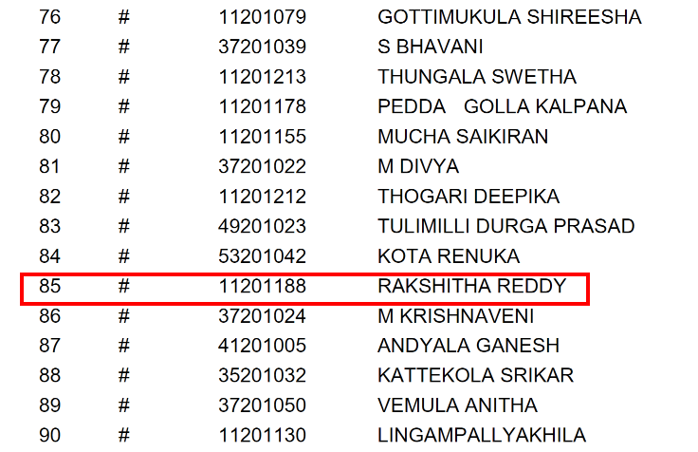

|  |  |  |  |  |  |  |  |
| --- | --- | --- | --- | --- | --- | --- | --- |
|  |  |  |  | | | | |
| [**S.No.**](http://s.no/) | **Class** | **Group** | **Name of the student** | [**Reg.No**](http://reg.no/) | **Applied Subject** | [**H.T.No**](http://h.t.no/) | **Short Listed or Not** |
| 1 | [B.Sc](http://b.sc/) | BZC | MANTHENA RAKSHITHA | 2114645 | MA(Telugu) | 11201188 | Short Listed |
| 2 | [B.Sc](http://b.sc/) | MPC | R PRATHYUSHA | 2155640 | physics |  |  |
| 3 | [B.Sc](http://b.sc/) | MZC | BANDARI GODHAVARI | 2138212 | Molecular Microbiology |  | No |
| 4 | [B.Sc](http://b.sc/) | MSCS | KAMBLE RAGINI | 2141217 | maths/applied maths |  |  |
| 5 | [B.Sc](http://b.sc/) | MSCS | THOTA RADHIKA | 2112099 | Statistics | 35021033 |  |
| 6 | B.A | HEP | THOTAPELLI MAMATHA | 2168515 | English | 53171062 |  |
| 7 | B.A | HEP | DASARI RAMYA | 2162569 | political science |  |  |
| 8 | B.A | HEP | GOLETI LAVANYA | 2168190 | Economics |  | No |
| 9 | B.A | HEP | GUNDENA SAISREE | 2136113 | Political Science & History | 41281022 | No |
| 10 | B.A | HEP | HEMLE MAYAVATHI | 2150908 | Political Science | 41281024 | No |
| 11 | B.A | HEP | JYOTHI GANDHAM | 2155173 | Political Science | 35281016 |  |
| 12 | B.A | HEP | LAMBADE DEEKSHA | 2143849 | Political Science | 41281029 |  |
| 13 | [B.Com](http://b.com/) | General | EEDULLA MEGHANA | 2109785 | MBA(Business Analytics) |  |  |

**2020-2021 Proofs**

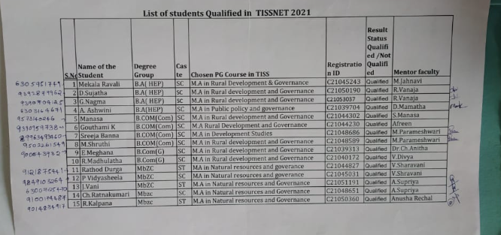

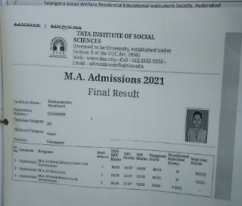

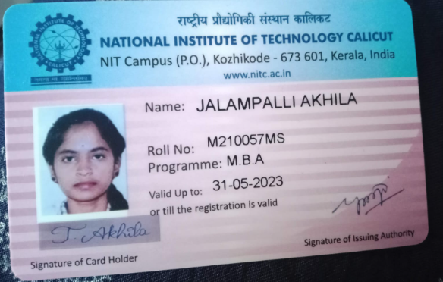

**2019-2020**

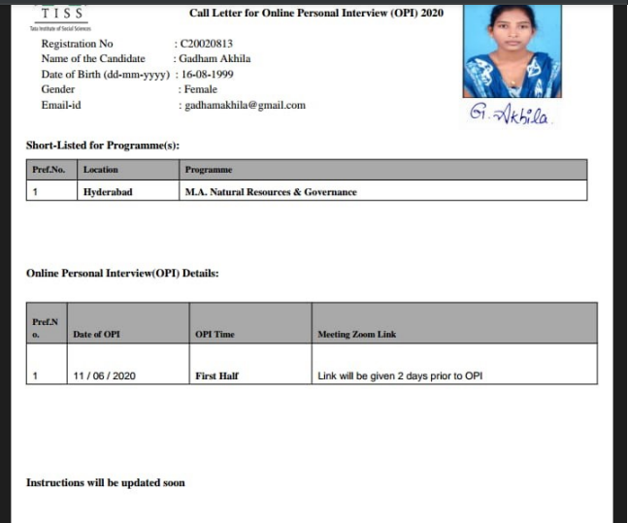

**2018-2019 Proofs**

